LAB07 - System and Clock control (simulated).
Let's start the project!
1. Create the directory named 'Lab07'. Download, unzip and copy file 'Template_Lab07.s' into your 'Lab07' directory. Rename 'Template_Lab07.s' to 'JoeTheStudent_Lab07.s' where 'JoeTheStudent' is your name or canvas login. Open 'Keil uVision' and create new project 'Lab07' like you did it for Lab05. Use usual project's settings.
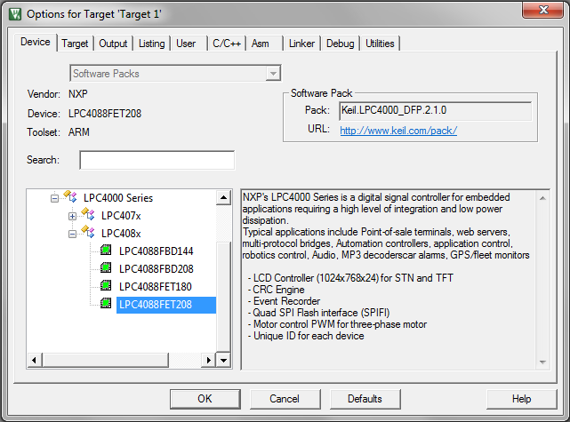
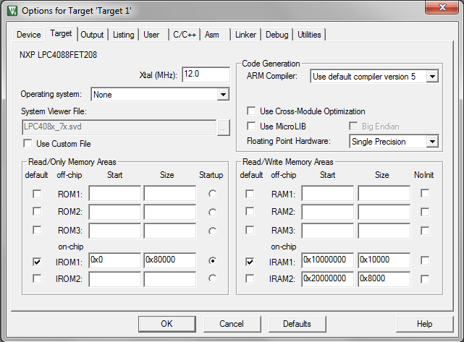
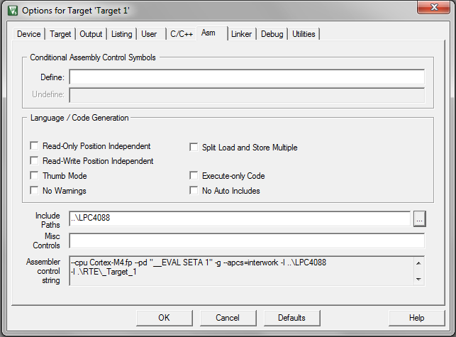
On ‘Asm’ tab, go to ‘Include Paths’ edit box and type ‘..\LPC4088’. It is important!
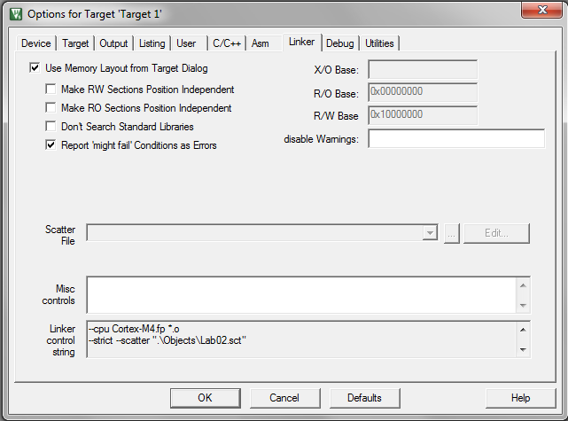
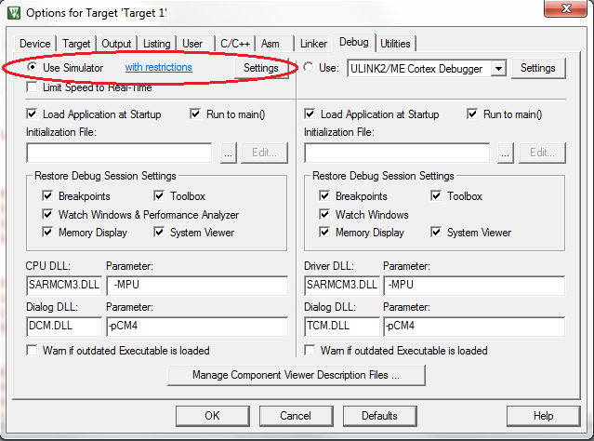
Important! We will use ‘Simulator’ for this Lab!
Part A
In part A you will write four subroutines and test it.
2. Add 'JoeTheStudent_Lab07.s' and 'LPC4088\startup_LPC407x_8x_177x_8x.s' files into your project. In ‘Add File’ dialog you will need to navigate to ‘..\LPC4088’ directory. Use standard ‘Up One Level’ button. Open 'JoeTheStudent_Lab05.s' file.
3. Locate the following fragment of text (second half of file):
;
; 1. Write a function to find MAX and MIN of array of signed 16-bin integers.
;
; Parameters:
;
; R0 - Input: Address of array (signed half-words)
; R1 - Input: Size of array ( >= 1 )
;
; R2 - Output: Min(array)
; R3 - Output: Max(array)
;
; Preserve the values of R0, R1 and any registers you are using in your function.
;
min_max
; -- Your code for function is here ---
ALIGN

Replace '; -- Your code for function is here ---', line with instructions of your 'min_max' subroutine.
Use all good techniques you learned from previous lecture:
- Use BL command to call the procedure!
- Store all registers used in subroutine into stack!
- Do not store register(s) that will return the result!
- Number of register(s) in PUSH and POP commands should match!
- Store LR into stack as well
- Use POP {…, PC} as ‘return’ command

4. When you done and your subroutine is ready to run and test, go to upper half of the file and locate the fragment:
; Test 'min_max'
;
; vvvvvv Uncomment when procedure 'min_max' is ready to test! vvvvv
; LDR R1, =N_MIN_MAX
; LDR R0, =min_max_data_1
; BL min_max ; Expected results: Min: -3 (0xFFFFFFFD) Max: 13 (0x0000000D)
;;
; LDR R0, =min_max_data_2
; BL min_max ; Expected results: Min: 1 (0x00000001) Max: 16 (0x00000010)
;;
; LDR R0, =min_max_data_3
; BL min_max ; Expected results: Min: -16 (0xFFFFFFF0) Max: -1 (0xFFFFFFFF)
; ^^^^^^^^^^^^^^^^^^^^^^^^^^^^^^^^^^^^^^^^^^^^^^^^^^^^^^^^^^^^^^^^^

5. Uncomment lines between '; vvvvvv Uncomment when... ' and '; ^^^^^^^^^^^...'. The fragment should looks like:
; Test 'min_max'
;
; vvvvvv Uncomment when procedure 'min_max' is ready to test! vvvvv
LDR R1, =N_MIN_MAX
LDR R0, =min_max_data_1
BL min_max ; Expected results: Min: -3 (0xFFFFFFFD) Max: 13 (0x0000000D)
;
LDR R0, =min_max_data_2
BL min_max ; Expected results: Min: 1 (0x00000001) Max: 16 (0x00000010)
;
LDR R0, =min_max_data_3
BL min_max ; Expected results: Min: -16 (0xFFFFFFF0) Max: -1 (0xFFFFFFFF)
; ^^^^^^^^^^^^^^^^^^^^^^^^^^^^^^^^^^^^^^^^^^^^^^^^^^^^^^^^^^^^^^^^^
6. Set breakpoint to ' LDR R1, =N_MIN_MAX' command.

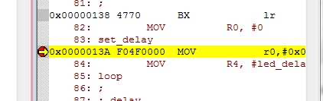

7. Use 'build target'  and 'start debug'  commands/buttons to compile, load your program. (Remember LAB01, LAB02).
Use run, step execution commands/buttons (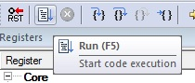 and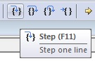) to run the program and see results. Debug your instructions if necessary.
8. Repeat steps 2 - 7 for all assignments ##2 and 3. Make sure your functions work for all test cases.
9. Ask your questions by e-mail! You will be answered promptly!
10. Zip and submit 'JoeTheStudent_Lab07.s' file when done.

